SDM Research Office
Welcome Message

Welcome to the Research Office of the UConn School of Dental Medicine (SDM)! Our mission is to provide high-quality research support to all researchers in the SDM.
To help achieve this goal, our office has been substantially reorganized and expanded. We now provide comprehensive centralized pre-award and post-award grants management to investigators in the SDM. We also provide support for student research, for our institutional T90/R90 training grants including the DMD/PhD program, and for the PhD program in Skeletal Biology and Regeneration. In addition, the SDM Research Office facilitates support to SDM researchers in various areas including scientific editing and statistical support.
Over the last few years, the number of grant submissions from the SDM as well as the amount of extramural funding received has grown substantially. In FY2021, we submitted 94 grant proposals and received $11.72M in extramural funding. The growth and success of our research programs has contributed to us achieving our highest ever research ranking based on total NIH funding for FY2020.
The staff of the SDM Research Office are highly trained and experienced in grants administration. Recent faculty feedback on their services has been overwhelmingly positive. In May 2021, the SDM Research Office staff team was recognized with the UConn Health PAWS TEAM award, which recognizes outstanding performance by a team in support of the UConn Health mission. We look forward to maintaining and improving on these high standards in service of our research community.

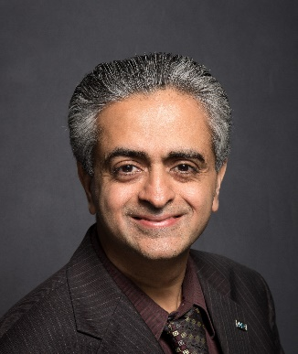
Sincerely,
Rajesh V. Lalla, DDS, PhD
Associate Dean for Research
lalla@uchc.edu

Research Office Staff

Laura Didden, CRA  Manager, SDM Research Office  ldidden@uchc.edu  Phone: 860-679-3891 | 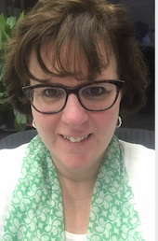
Annmarie Martin  amartin@uchc.edu  Phone: 860-679-2548 | 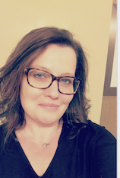
Brandon Mulcunry  bmulcunry@uchc.edu  Phone: 860-679-7652 | 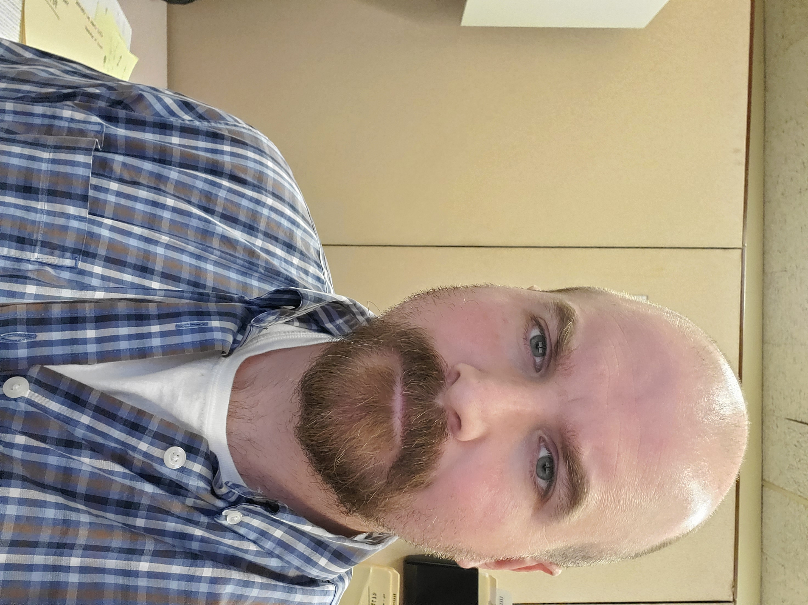
Lisa Ramsdell  ramsdell@uchc.edu  Phone: 860-679-2552 | 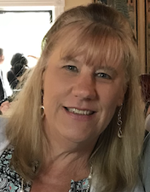
Kamal Sahoobah  sahoobah@uchc.edu  Phone: 860-679-6012 | 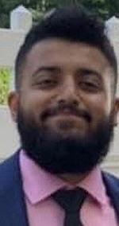
Robin Tiso  rtiso@uchc.edu  Phone: 860-679-3023 | 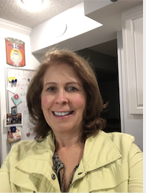
Caibin Zhang  czhang@uchc.edu  Phone: 860-679-4498 | 